Featurization techniques for images called **Image Histograms:**

Remember now a days this techniques are not used, this are very basic, CNN is used mostly now a days.

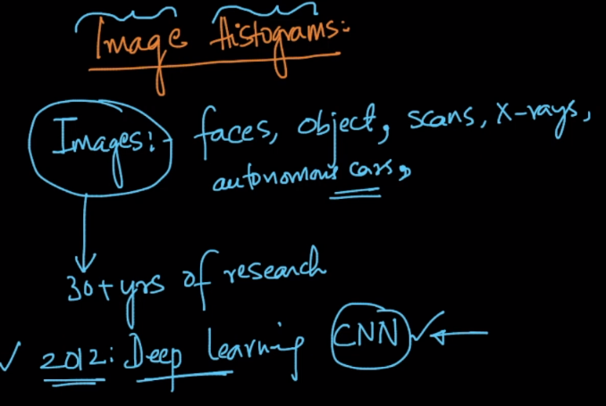

**Color histogram:**

Wkt each color is represented in 3 colors RGB, so what we do is as follows:

* At each pixel find the value of Red color.
* Plot pdf for Red color, where x-axis will be 0-255 (since max color values is 255).
* Now we find make percentage of point at each color value as feature:

Example at 10, there are 35% of pixels, or 35% of pixels have value equal to 10.

So feature 10 will have 0.35 as value, similarly we find all 255 features.

We repeat same thing for green and blue also.

But this technique is only useful for small image task, like detecting sky or sunrise. Or face detection but it can’t identify shapes.

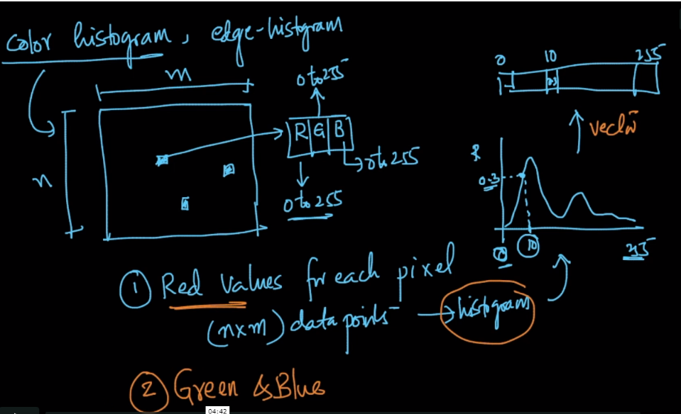

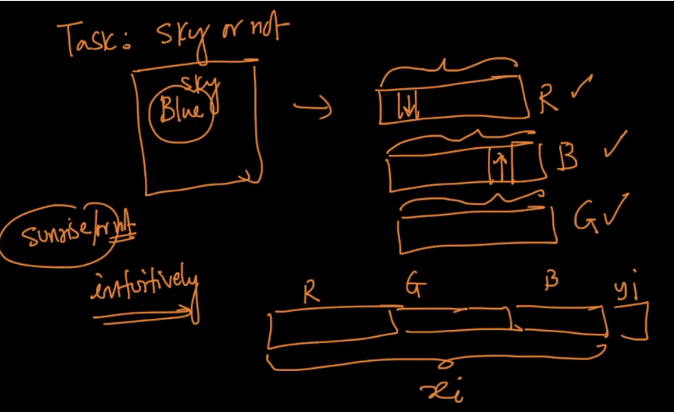

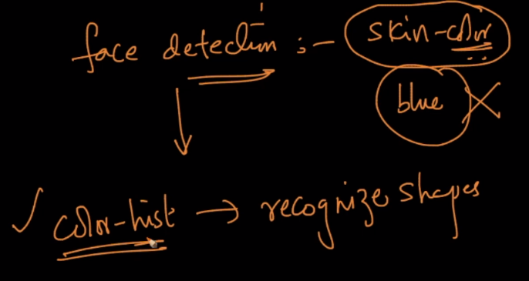

**Edge histograms:**

Image is divided into ‘n’ regions and in each region we find a edge which divides. Like above line we have other color and below we have another color.

We can have more than one edge in a region, but we select dominant edge(which is long and thick).

We note down the angle of dominant edge for each region.

And if any region don’t have any edge then -1 is assigned to that.

Now we draw pdf of this wrt to angle, where x axis will be from -1 to 180 degree.

And therefore we will have 181 features, where each feature will contains the count of regiions having that angle.

